**CARESTREAM HEALTH**

|  |  |
| --- | --- |
| **Part Number :** | **Autour : Ralf Wang** |
| **Project : KIOSK PUMA CS System** | **Product : KIOSK** |
| **Document Title: Kiosk PUMA CS Performance Testing Report** | |

**TABLE OF CONTENTS**

[1 Test Environment 2](#_Toc484421685)

[2 Test Requirement 2](#_Toc484421686)

[2.1 Test Scenario 3](#_Toc484421687)

[2.2 Test Tool 3](#_Toc484421688)

[3 Testing work （Phase 1） 4](#_Toc484421689)

[3.1 Strategy and Scenario Setting 4](#_Toc484421690)

[3.2 Background Data 4](#_Toc484421691)

[3.3 Other Setting: 5](#_Toc484421692)

[3.3.1 Database setting 5](#_Toc484421693)

[3.3.2 IIS setting 5](#_Toc484421694)

[3.4 Test Object version 5](#_Toc484421695)

[3.5 Test Error 5](#_Toc484421696)

[3.6 Test result 6](#_Toc484421697)

[3.6.1 Transactions result 6](#_Toc484421698)

[3.6.2 Test Statistic Report 6](#_Toc484421699)

[3.6.3 Transaction summary result: 7](#_Toc484421700)

[3.6.4 Transaction response time result 7](#_Toc484421701)

[3.7 Performance bottleneck analysis 8](#_Toc484421702)

[3.7.1 Hardware usage analysis 8](#_Toc484421703)

[3.7.2 SQL Server resource usage analysis 10](#_Toc484421704)

[3.8 Test Conclusion 12](#_Toc484421705)

[3.9 Tune Suggesting 12](#_Toc484421706)

[3.9.1 Slowly SQL statement 12](#_Toc484421707)

[3.9.2 Deadlock SQL 14](#_Toc484421708)

[3.9.3 Other 14](#_Toc484421709)

# Test Environment

Test environment：We use the follow machine to do our performance testing work.

|  |  |  |  |  |  |  |  |  |  |  |  |
| --- | --- | --- | --- | --- | --- | --- | --- | --- | --- | --- | --- |
| **Server Name** | **Type** | **CPU** | | **Hard Disk** | | **RAM** | | **OS** | | **Required Software** | |
| CS Server | Hyper-v virtual machine | Intel core(TM) i7-6700 3.40GHz \*2 | 200G SCSI Disk  Seagate MD3002 | | 8G | | Windows 2008 R2 Standard | | MySQL Server 5.7  IIS 7 | |
| Performance control | Dell optiplex 9020 | Intel core(TM) i7-4790 3.6GHZ\*6 | 1T SATA Disk | | 8G | | Win7 64bit | | Load runner | |

Figure 1.1 Hardware List

# Test Requirement

The PUMA system will support report printing and notice push service for different department of entire hospital. We will integrate the 3rd party system and patients can print their reports in ONE terminal. The message push service will also be included in the product. Patients can query different information, and get report status notice service from the product. The architecture as follow:

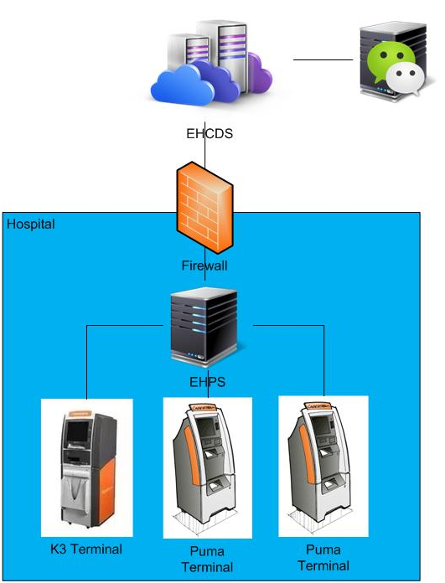

Figure 3.1.1

We will focus on the CS system performance testing work. We will simulate the web service call and send requests to CS server, and monitor the transactions response time, service performance and hardware resource usage. This scenario will include get the 2D Image code, register users for WeChat, push the message to users, query report film status change, create reservation and query etc.

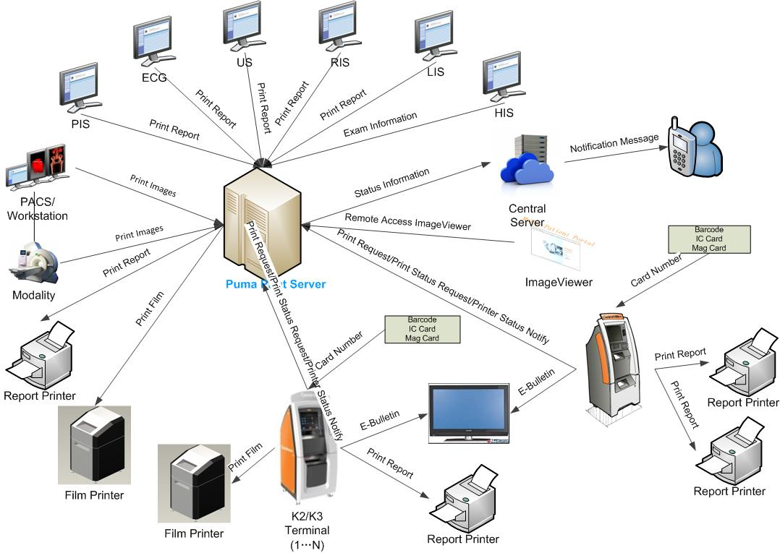

Figure 3.1.2

## Test Scenario

The testing work will simulate the real work flow include get the 2D Image code, register users for WeChat, push the message to users, query report film status change, create reservation and query etc.

This scenario is smoking test, we should to verify the system can work well under current stress.

## Test Tool

Load Runner: Simulate the patient operations by http or web service.

# Testing work （Phase 1）

## Strategy and Scenario Setting

1. Simulate the 3rd system to get the We chat QR code by web service and get the related information from database.
2. Subscribe the users by We chat service and give the open ID for users.
3. Create the patient report information and make it status from created to printed. The local service will push the message to users with database or service trigger.
4. Create the patient film information and make it status from created to printed. The local service will push the message to users with database or service trigger.
5. Create patient reservation information and make it reservation date is next day. The reservation information will update randomly.
6. Set the operations of step3 – step4 execute randomly and the value is 45%,45% and 10%.
7. Create patient query operations after step3-step5.
8. Prepare 10 virtual users to simulate the operations from step1 to step7.
9. Monitor the hardware resource usage on CS.
10. Monitor the resource usage for database on CS.
11. Start/Stop 2 virtual users every 5 seconds and run the scenario for 8 hours.

## Background Data

We use SQL command statement to add large data in the database, the detail information as follow:

|  |  |
| --- | --- |
| **Table Name** | **Data Volume (records)** |
| ECS.filmreportstatus | 0 |
| ECS.examreservation | 0 |
| ECS.notificationmessage | 0 |
| ECS.wechatclient | 0 |
| ECS.qrcodesceneinfo | 0 |
|  |  |

Figure 3.2.1 Background Data

## Other Setting:

### Database setting

Keep all parameters with install default.

### IIS setting

Default value.

## Test Object version

CS version 3.0.3.0.190

## Test Error

There are some errors exist in the testing work and logged as follow:

|  |  |  |
| --- | --- | --- |
| No | description | Counts |
| 1 | A\_Patient\_Register.c(74): Continuing after Error -26377: No match found for the requested parameter "Get2DCodeImageResult". Either the specified boundaries were not found in the response or the matched text is longer than current max html parameter size of 10240 bytes. The total length of the response is 300 bytes. You can use "web\_set\_max\_html\_param\_len" to increase the max parameter size. | 64 |
| 2 | A\_Patient\_Register.c(101): Error: Get2DCodeImage from CS operations failed. The http response content size is 0! | 511241 |
| 3 | A\_Patient\_Register.c(72): Error: Cannot start transaction "Patient operations\_ Get2DCodeImage". This Vuser already started a transaction with the same name, and has not yet processed the corresponding lr\_end\_transaction statement. | 54 |
|  |  |  |
|  |  |  |
|  |  |  |
|  |  |  |

Error analyzes:

Follow these error messages, we can find that the get 2D code Image services failed frequently. This error will affect other patient operations such as register and query operations because the step is the precondition. We should fix the issues in next testing works.

## Test result

### Transactions result

After the testing work, the related records increased in database as follow:

|  |  |
| --- | --- |
| **Table** | **Increase count** |
| ECS.filmreportstatus | 6767 |
| ECS.examreservation | 766 |
| ECS.notificationmessage | 28594 |
| ECS.wechatclient | 7470 |
| ECS.qrcodesceneinfo | 7534 |

Figure 3.6.1.1 Test result from DB

### Test Statistic Report

|  |  |
| --- | --- |
| Analysis Summary | Period: 19/03/2018 17:20:38 - 20/03/2018 05:52:09 |

|  |  |
| --- | --- |
| **Scenario Name:** | Scenario1 |
| **Results in Session:** | D:\ECS\CS\_Patient\_Query\_opertion\res\res.lrr |
| **Duration:** | 12 hours, 31 minutes and 31 seconds. |

|  |
| --- |
| Statistics Summary |

|  |  |  |
| --- | --- | --- |
| [**Maximum Running Vusers:**](file:///C:\Users\19007296_local\AppData\Local\Temp\VuserStateGraph) |  | 10 |
| [**Total Throughput (bytes):**](file:///C:\Users\19007296_local\AppData\Local\Temp\Throughput) | [Show SLA Results](slarules:total_throughput) | 34,033,356 |
|  |  |  |
|  |  |  |
| [**Average Throughput (bytes/second):**](file:///C:\Users\19007296_local\AppData\Local\Temp\Throughput) | [Show SLA Results](slarules:average_throughput) | 755 |
|  |  |  |
|  |  |  |
| [**Total Hits:**](file:///C:\Users\19007296_local\AppData\Local\Temp\HitsperSecond) | [Show SLA Results](slarules:total_hits) | 39,319 |
|  |  |  |
|  |  |  |
| [**Average Hits per Second:**](file:///C:\Users\19007296_local\AppData\Local\Temp\HitsperSecond) | [Show SLA Results](slarules:average_hits) | 0.872 | [**View HTTP Responses Summary**](file:///C:\Users\19007296_local\AppData\Local\Temp\303268440.html#1) |
|  |  |  |  |
|  |  |  |  |

|  |  |  |
| --- | --- | --- |
| |  | | --- | | You can define SLA data using the [SLA configuration wizard](slaconfig:) | | You can analyze transaction behavior using the [Analyze Transaction mechanism](analyze:) | |

|  |
| --- |
| Transaction Summary |

|  |  |  |  |  |
| --- | --- | --- | --- | --- |
| [**Transactions:**](file:///C:\Users\19007296_local\AppData\Local\Temp\TransactionSummary) | Total Passed: 51,001 | Total Failed: 121 | Total Stopped: 0 | [**Average Response Time**](file:///C:\Users\19007296_local\AppData\Local\Temp\ResponseTime) |

|  |
| --- |
|  |

|  |  |  |  |  |  |  |  |  |
| --- | --- | --- | --- | --- | --- | --- | --- | --- |
| **Transaction Name** | **Minimum** | **Average** | **Maximum** | **Std. Deviation** | **90 Percent** | **Pass** | **Fail** | **Stop** |
| [Create ExamReservation](file:///C:\Users\19007296_local\AppData\Local\Temp\ResponseTime0000(Create%20ExamReservation)0000) | 0.106 | 1.48 | 5.444 | 0.672 | 2.411 | 643 | 0 | 0 |
| [Create Film](file:///C:\Users\19007296_local\AppData\Local\Temp\ResponseTime0000(Create%20Film)0000) | 0.172 | 1.192 | 5.043 | 0.804 | 2.309 | 3,009 | 0 | 0 |
| [Create Paper report](file:///C:\Users\19007296_local\AppData\Local\Temp\ResponseTime0000(Create%20Paper%20report)0000) | 0.181 | 1.186 | 5.104 | 0.784 | 2.32 | 2,995 | 0 | 0 |
| [Patient operations\_ Get2DCodeImage](file:///C:\Users\19007296_local\AppData\Local\Temp\ResponseTime0000(Patient%20operations_%20Get2DCodeImage)0000) | 0.233 | 0.859 | 2.414 | 0.23 | 1.099 | 6,603 | 121 | 0 |
| [QueryReportFilmStatus](file:///C:\Users\19007296_local\AppData\Local\Temp\ResponseTime0000(QueryReportFilmStatus)0000) | 0.004 | 1.306 | 8.041 | 0.864 | 2.216 | 11,792 | 0 | 0 |
| [QueryReportFilmStatus\_Pass](file:///C:\Users\19007296_local\AppData\Local\Temp\ResponseTime0000(QueryReportFilmStatus_Pass)0000) | 0 | 0 | 0 | 0 | 0 | 11,965 | 0 | 0 |
| [QueryReservation](file:///C:\Users\19007296_local\AppData\Local\Temp\ResponseTime0000(QueryReservation)0000) | 0.041 | 0.482 | 3.305 | 0.476 | 1.024 | 701 | 0 | 0 |
| [QueryReservation\_Pass](file:///C:\Users\19007296_local\AppData\Local\Temp\ResponseTime0000(QueryReservation_Pass)0000) | 0 | 0 | 0 | 0 | 0 | 702 | 0 | 0 |
| [Subscribe\_Patinet](file:///C:\Users\19007296_local\AppData\Local\Temp\ResponseTime0000(Subscribe_Patinet)0000) | 0.054 | 0.577 | 4 | 0.402 | 0.946 | 6,602 | 0 | 0 |
| [Update ExamReservation](file:///C:\Users\19007296_local\AppData\Local\Temp\ResponseTime0000(Update%20ExamReservation)0000) | 0.554 | 1.343 | 4.1 | 0.517 | 1.849 | 60 | 0 | 0 |
| [Update Film](file:///C:\Users\19007296_local\AppData\Local\Temp\ResponseTime0000(Update%20Film)0000) | 0.712 | 1.889 | 6.187 | 0.563 | 2.505 | 2,985 | 0 | 0 |
| [Update Paper report](file:///C:\Users\19007296_local\AppData\Local\Temp\ResponseTime0000(Update%20Paper%20report)0000) | 0.279 | 1.838 | 5.49 | 0.569 | 2.49 | 2,944 | 0 | 0 |

|  |  |  |  |  |  |  |
| --- | --- | --- | --- | --- | --- | --- |
| **Service Level Agreement Legend:** | C:\Users\19007296_local\AppData\Local\Temp\led_ok.gif | Pass | C:\Users\19007296_local\AppData\Local\Temp\led_error.gif | Fail | C:\Users\19007296_local\AppData\Local\Temp\led_no_data.gif | No Data |

|  |
| --- |
| HTTP Responses Summary |

|  |  |  |
| --- | --- | --- |
| **HTTP Responses** | **Total** | **Per second** |
| [HTTP\_200](file:///C:\Users\19007296_local\AppData\Local\Temp\HttpReturnCodes0001(HTTP_200)0001) | 39,318.8 | 0.872 |

Figure 3.6.2.1 Summary Report

Follow the summary result information; we can get the information that:

All testing work duration time is 12 hours and 31 minutes. There are 51001 transactions passed and 121 transactions failed.

|  |  |  |  |  |  |  |  |  |
| --- | --- | --- | --- | --- | --- | --- | --- | --- |
| **Transaction Name** | **Minimum** | **Average** | **Maximum** | **Std. Deviation** | **90 Percent** | **Pass** | **Fail** | **Stop** |
| [Patient operations\_ Get2DCodeImage](file:///C:\Users\19007296_local\AppData\Local\Temp\ResponseTime0000(Patient%20operations_%20Get2DCodeImage)0000) | 0.233 | 0.859 | 2.414 | 0.23 | 1.099 | 6,603 | 121 | 0 |

Figure 3.6.2.2 big value of response time

We monitor this issue and find the root reason is cause by the database. The error log information as follow:

2018-03-20 05:20:53,246 [29] ERROR Utility.Logger - Connection String: Server=localhost;Port=3306;Database=ECS;Uid=sa;Pwd=sa20021224$

MySql.Data.MySqlClient.MySqlException (0x80004005): Too many connections

at MySql.Data.MySqlClient.MySqlStream.ReadPacket()

at MySql.Data.MySqlClient.NativeDriver.Open()

at MySql.Data.MySqlClient.Driver.Open()

at MySql.Data.MySqlClient.Driver.Create(MySqlConnectionStringBuilder settings)

at MySql.Data.MySqlClient.MySqlPool.CreateNewPooledConnection()

at MySql.Data.MySqlClient.MySqlPool.GetPooledConnection()

at MySql.Data.MySqlClient.MySqlPool.TryToGetDriver()

at MySql.Data.MySqlClient.MySqlPool.GetConnection()

at MySql.Data.MySqlClient.MySqlConnection.Open()

at MySqlUtil.DBUtility.UpdateData(String sql)

The connection in MySQL database is 100 as default value; we should enhance the value or change the automation script in order to enhance the system and testing work.

### Transaction summary result

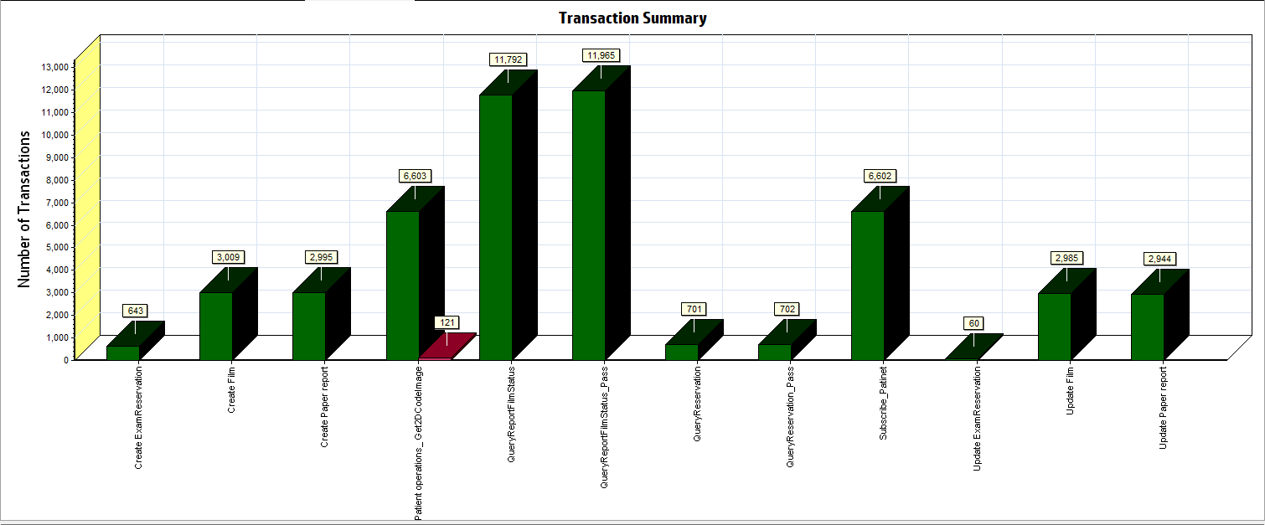

Figure 3.6.3.1 Transaction Summary

We can notice that there are some transactions failed during the testing work. We should find out the reason and fix it in the next version.

### Transaction response time result

We can get the transaction response time information from the figure as follow:

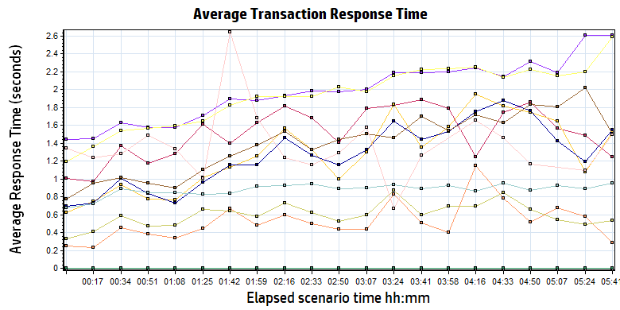

|  |  |  |  |  |  |  |  |  |
| --- | --- | --- | --- | --- | --- | --- | --- | --- |
| Color | | Scale | Measurement | Minimum | Average | Maximum | Std. Deviation | |
|  | | 1 | Create ExamReservation | 0.106 | 1.480 | 5.444 | 0.672 | |
|  | | 1 | Create Film | 0.172 | 1.192 | 5.043 | 0.804 | |
|  | | 1 | Create Paper report | 0.181 | 1.186 | 5.104 | 0.784 | |
|  | | 1 | Patient operations\_ Get2DCodeImage | 0.233 | 0.859 | 2.414 | 0.230 | |
|  | | 1 | QueryReportFilmStatus | 0.004 | 1.306 | 8.041 | 0.864 | |
|  | | 1 | QueryReportFilmStatus\_Pass | 0.000 | 0.000 | 0.000 | 0.000 | |
|  | | 1 | QueryReservation | 0.041 | 0.482 | 3.305 | 0.476 | |
|  | | 1 | QueryReservation\_Pass | 0.000 | 0.000 | 0.000 | 0.000 | |
|  | | 1 | Subscribe\_Patinet | 0.054 | 0.577 | 4.000 | 0.402 | |
|  | | 1 | Update ExamReservation | 0.554 | 1.343 | 4.100 | 0.517 | |
|  | | 1 | Update Film | 0.712 | 1.889 | 6.187 | 0.563 | |
|  | | 1 | Update Paper report | 0.279 | 1.838 | 5.490 | 0.569 | |
|  | | | | | | |

Figure 3.6.4.1 Transaction response time

We can find that the average response time for all transaction is less than 3 seconds.

## Performance bottleneck analysis

### Hardware usage analysis

We can get the hardware usage information from the figure as follow:

N/A

|  |
| --- |
|  |

Figure 3.6.4.1 Transaction response time

We do not monitor the server hardware resource usage because this phase testing work is smoking test. We will do this work next phase.

### MySQL Server resource usage analysis

We can get the MySQL server resource usage information from the figure as follow:

N/A

|  |
| --- |
|  |

Figure 3.7.2.1 Database result

|  |
| --- |
| C:\Users\Administrator\Desktop\Performance result\20170531_1\Report\dot_trans.gif |

We do not monitor the server hardware resource usage because this phase testing work is smoking test. We will do this work next phase.

## Test Conclusion

As current hardware and software setting, the system performance cannot meet the requirements of design. There are only 6,602 patients subscribed in CS in 12 hours but the goal is subscribe 10,000 patients in 8 hours.

Some transactions are failed; the database settings need update and enhance the performance.

The issues summary information as follow:

1. Some transaction is failed which cause by database or service. It must be resolve before publish.
2. The wechat service has some limited and we need design a mock service to confirm the message can push and query successfully.

We execute the performance testing scenario without database and mock service. We do this testing work in order to test the original performance under the current configurations. We should do some enhance works such as update the setting of database; update the test script and so on. After the develop team publish the mock service, we will start the real testing work as soon as possible.

QA team will continue design the test script and update the settings of DB to enhance the system performance.

Describe the overall verification and validation testing objectives.

Please make appropriate modifications to the sample text so it accurately reflects this project.

**<End of Document>**